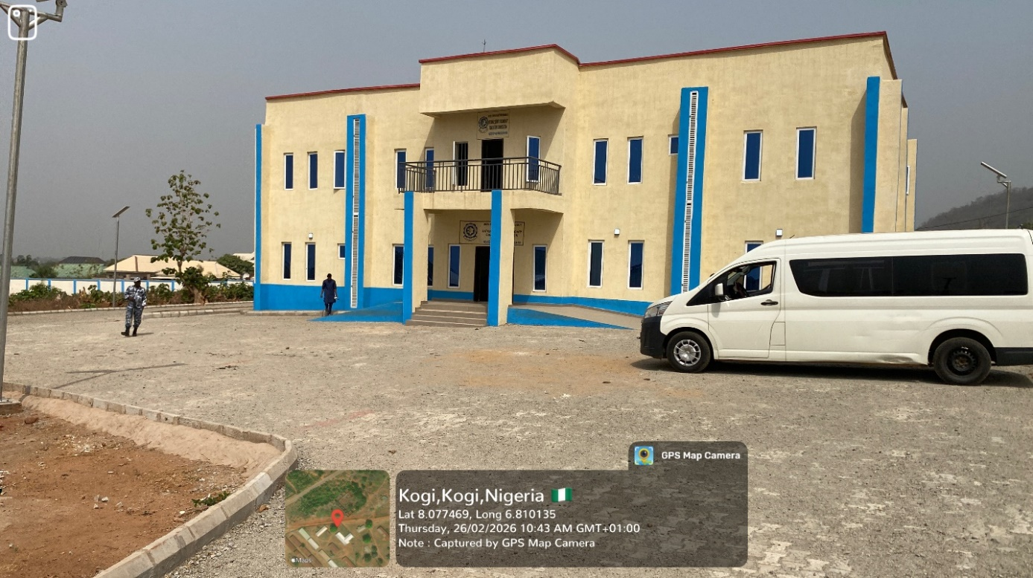
ADMIN BLOCK
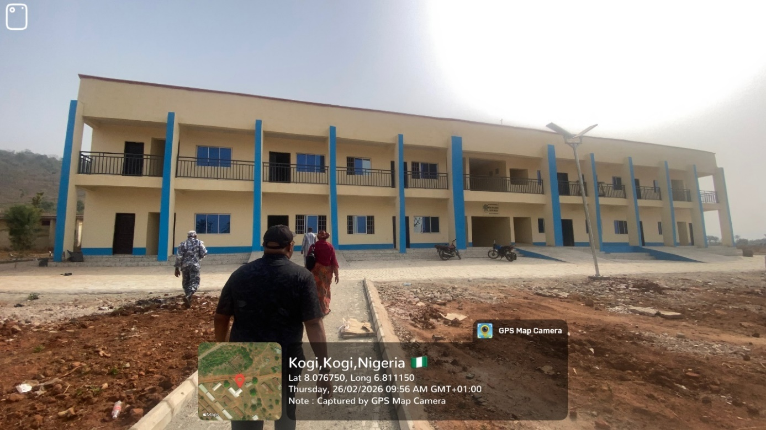
LABORATORY / ICT BLOCK

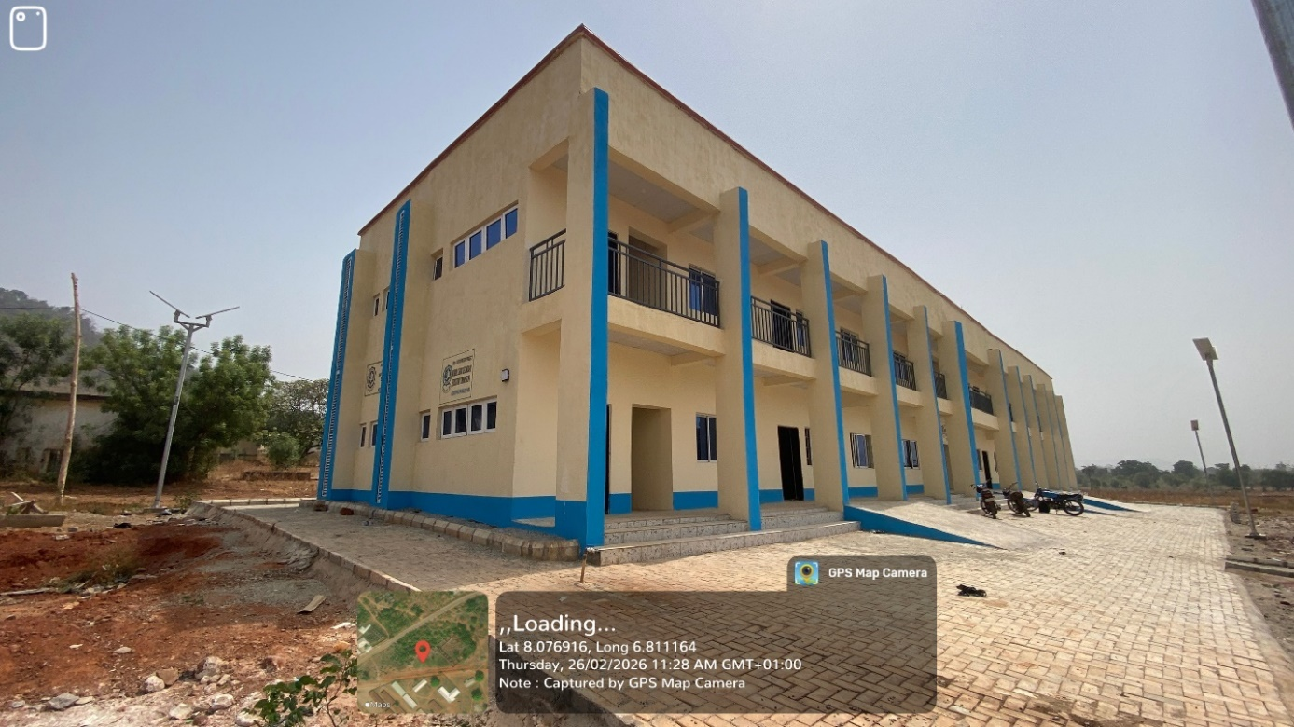
SIDE VIEW OF CLASSROOM BLOCK

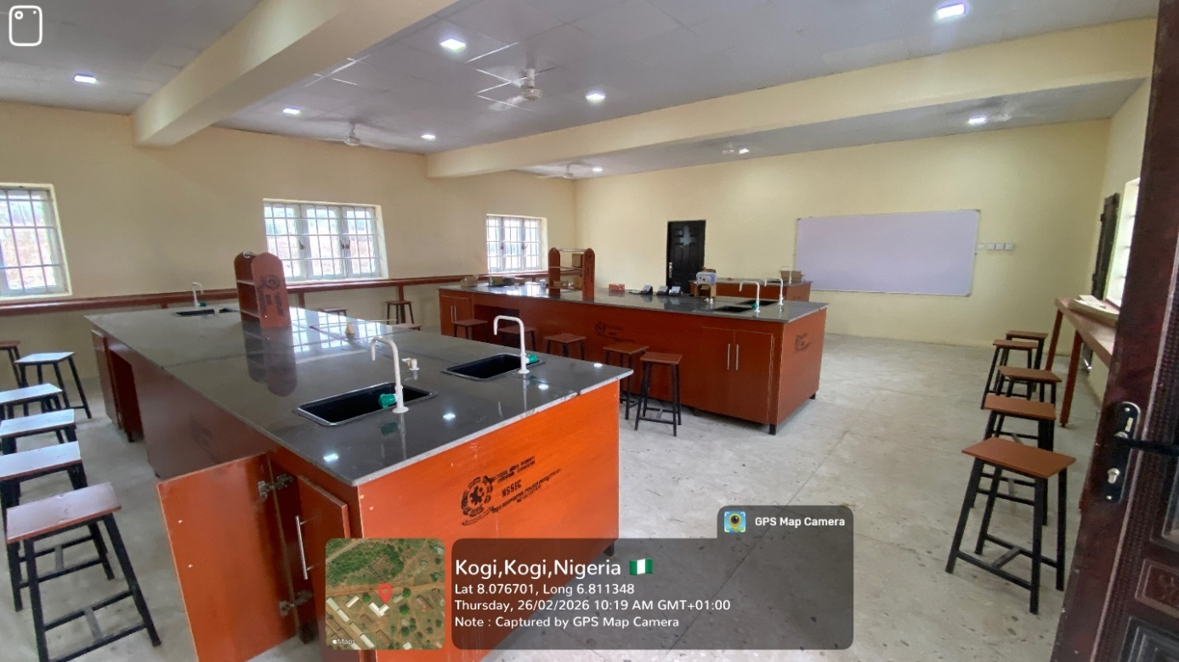
INTERIOR OF LABORATORY
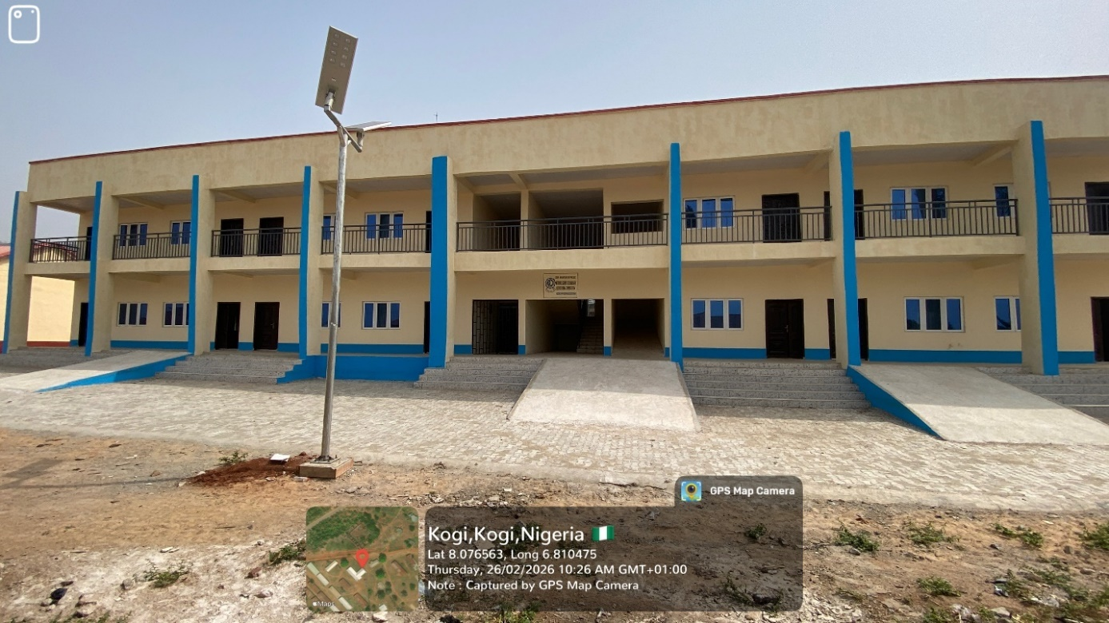
6 NR CLASSROOM BLOCK

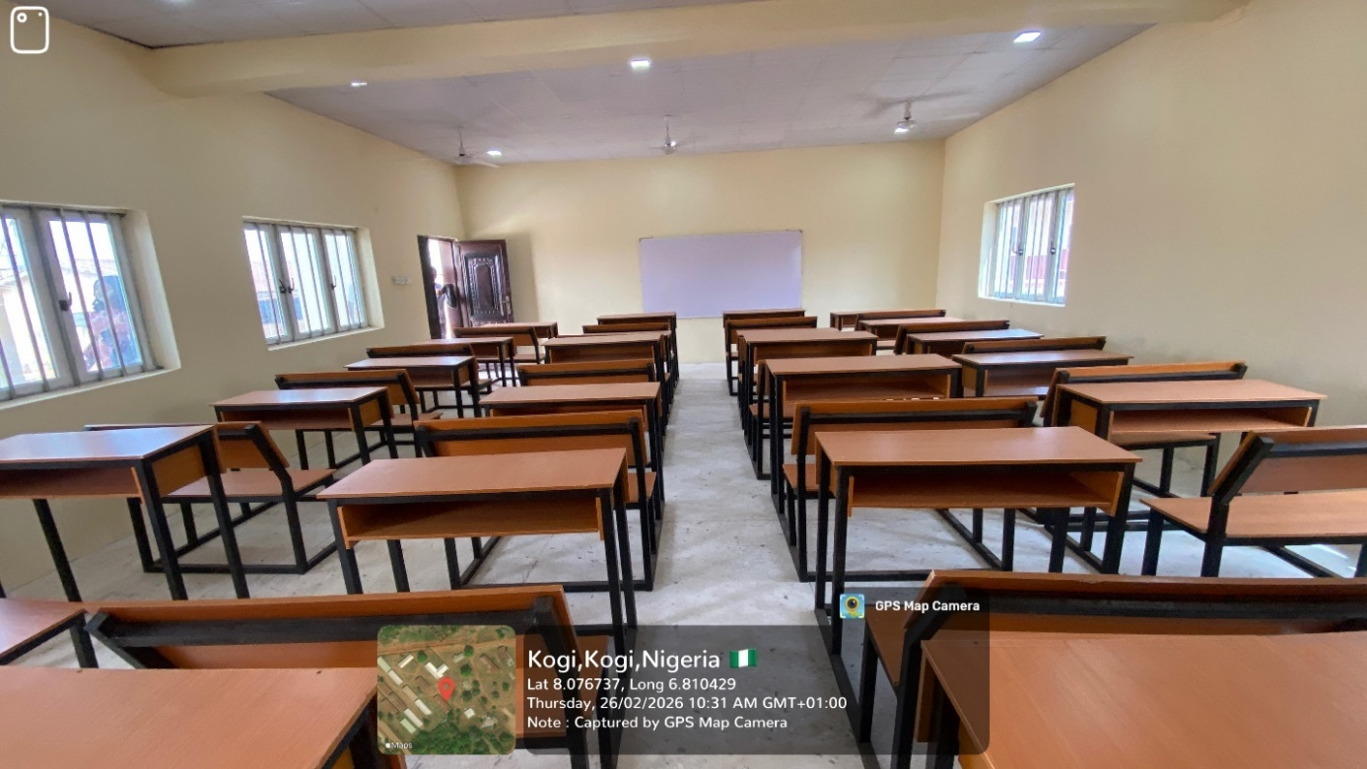
INTERIOR VIEW OF CLASSROOM BLOCK

